CPS/APS Hotline Internal Email Template

Help the Maryland Department of Human Services spread the word about the state’s new Child Protective Services + Adult Protective Services hotline! Use this internal email template to share information about the hotline with your organization’s staff. Be sure to include one of the agency’s promotional flyers about the hotline in the email.

Suggested Subject Line: The Maryland Department of Human Services Has Launched A New, 24-Hour Statewide Hotline for Abuse/Neglect Reporting and Preventative Services!

Dear employees,

I’m writing to share some exciting news with you about a new initiative that’s beneficial to Marylanders. The Maryland Department of Human Services (DHS) has launched a new, 24-hour statewide hotline that streamlines all abuse and neglect reporting calls in Maryland and connects families to the preventative services they need to thrive.

Check out the flyer below to learn more!

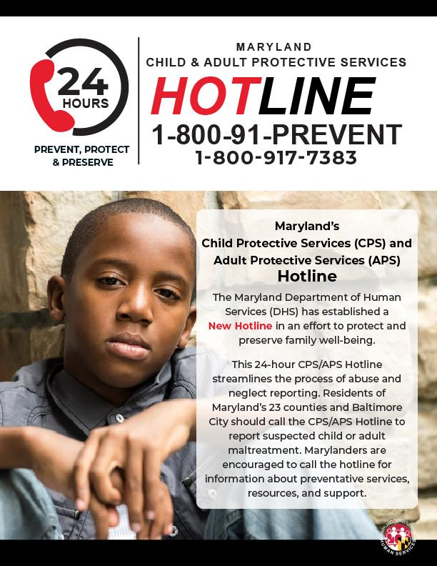

Please also consider visiting dhs.maryland.gov/hotlineoutreach/ for a comprehensive toolkit of materials worth sharing with the families you interact with about the hotline and all it has to offer.

Have a great rest of your day.

